SAVEETHA SCHOOL OF ENGINEERING
SAVEETHA INSTITUTE OF MEDICAL AND TECHNICAL SCIENCES
INSTITUTE OF CSE
CSA15- CLOUD COMPUTING AND BIG DATA ANALYTICS
LIST OF EXPERIMENTS
5. Create a simple cloud software application for Mark Sheet Processing System using
any Cloud Service Provider to demonstrate SaaS include the necessary fields such as
name of the student, Reg no of the student, Subjects, Marks, Average, percentage,
rank, overall performance etc.
INPUT:
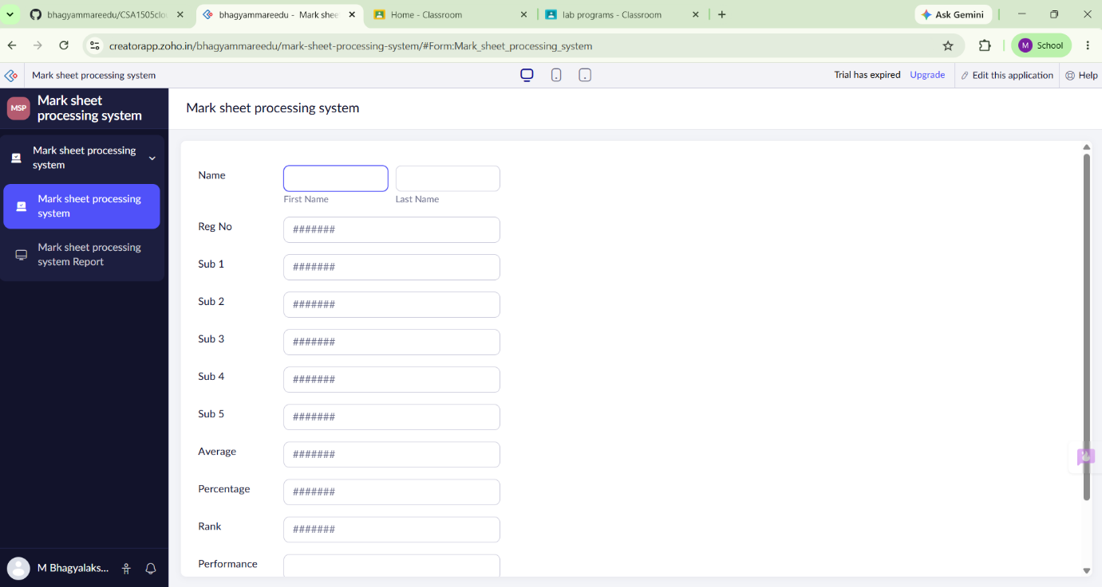

OVER VIEW:
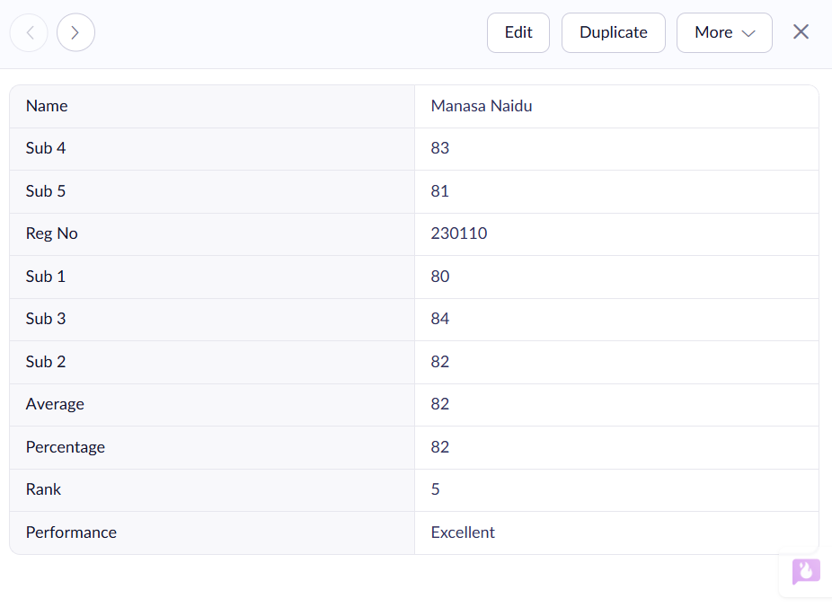
OUTPUT:
